**Sector Analysis – Bank**

**Performance: Parameters**

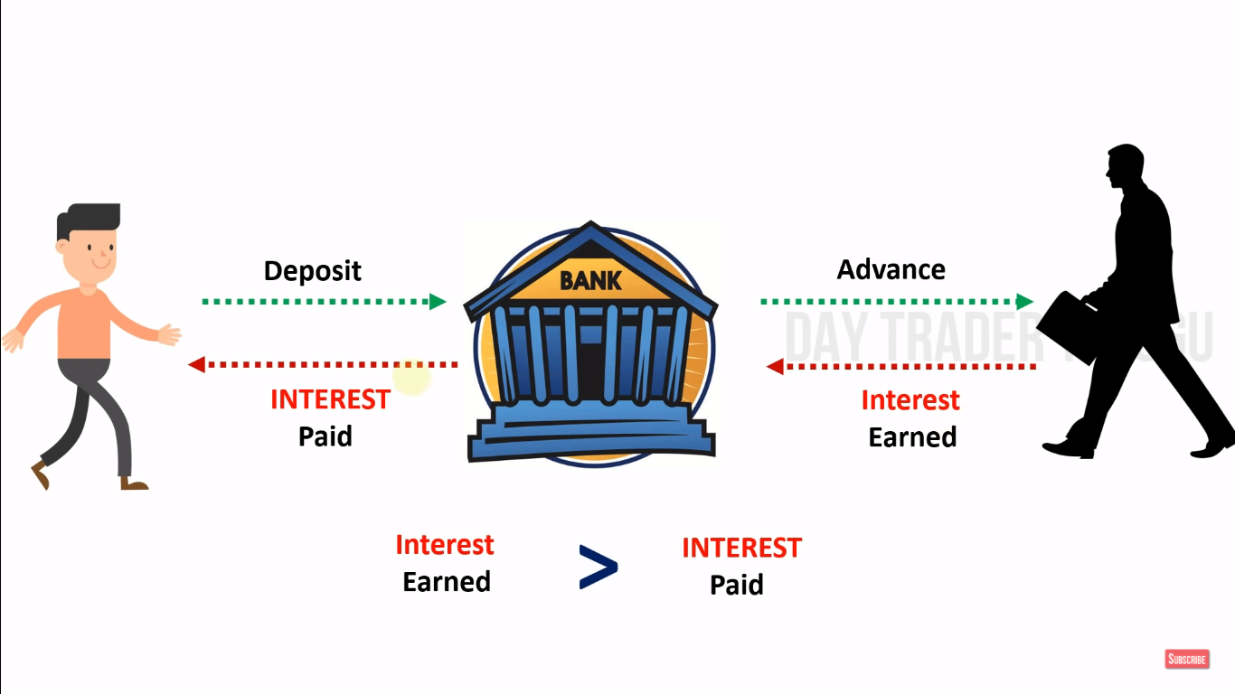

Deposits: Amount invested by customers -- Interest Paid (**4%**)

Advance: Loan provided to customers -- Interest Earned (**12%**)

Note: RBI will not allow to use 100% of deposits into Advances

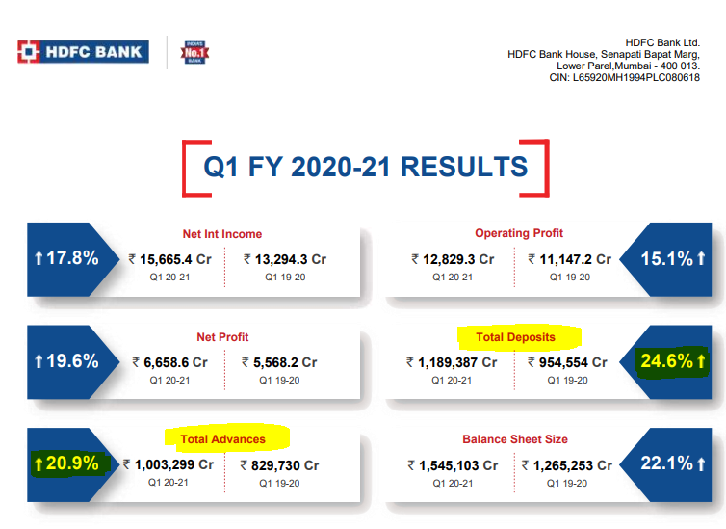

**CASA**

Current Account (CA) ---- No need to pay any Interest to customers (0%)

Saving Account (SA) ---- Very nominal interest (**2%-7%**) & vary from Bank(SBI) to Bank(HDFC)

Total Deposits (100%) – CASA (40%)

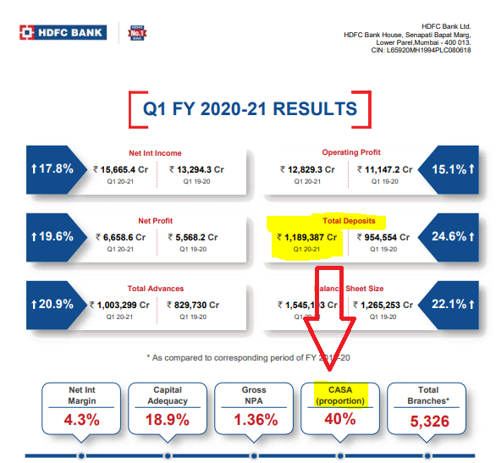

**Cost of Funding**

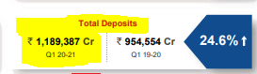

**Total Interest paying to deposits**

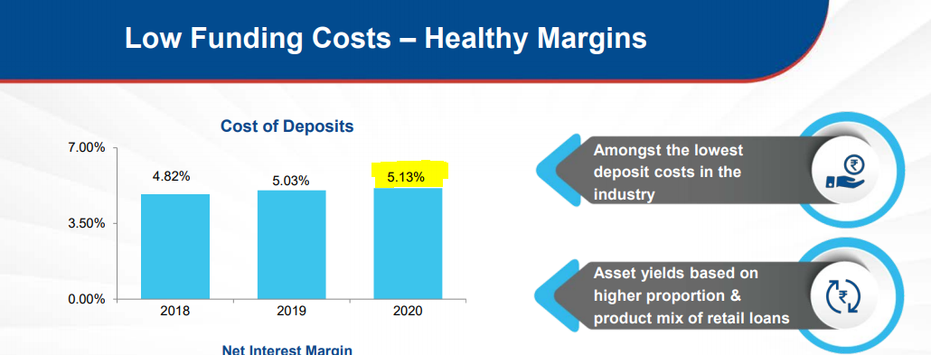

Example:

|  |  |  |  |
| --- | --- | --- | --- |
| **Bank** | **Interest paying to customers** | **CASA** | **COF** |
| Canara Bank | 5% | 31.38% | **5.36%** |
| IDFC First Bank | 7% | 32.16% | 8.35% |

As comparing to IDFC First Bank – Canara bank got the deposits for cheap interest **(Good for company)**

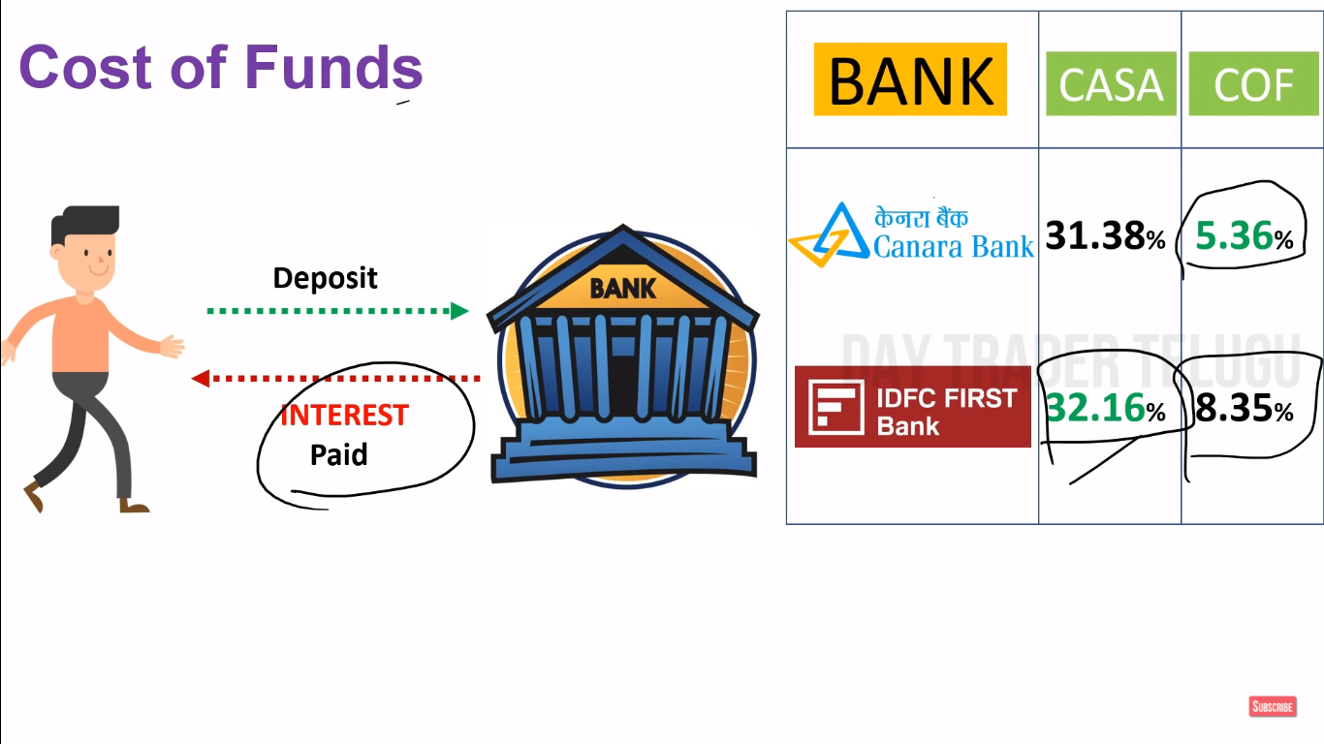

**Net Interest Income (NII)**

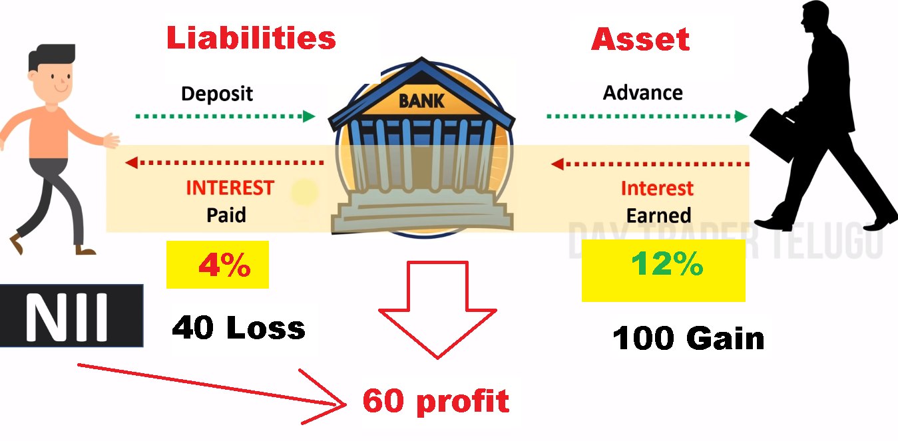

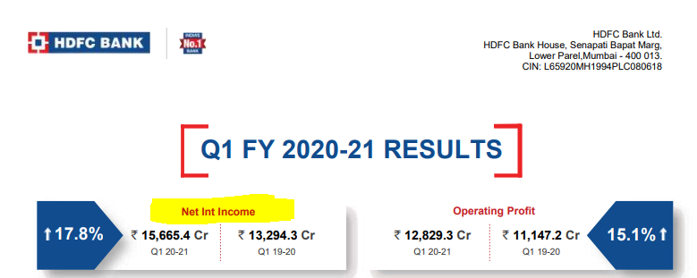

**Net Interest Margin (NIM)**

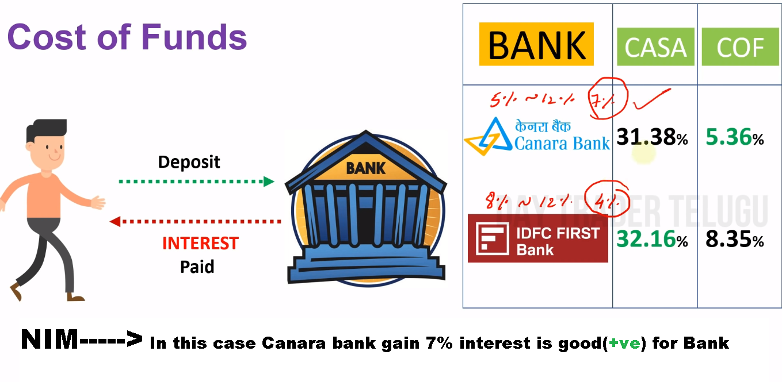

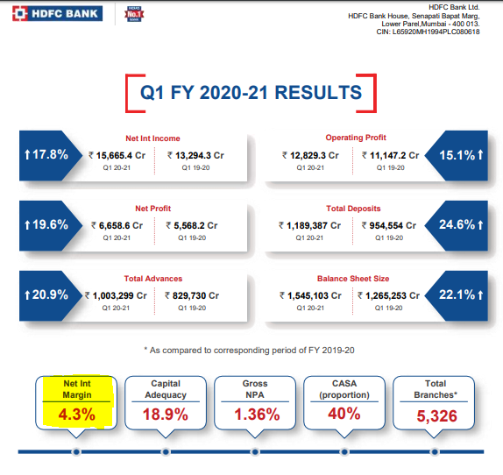

**Quality: Parameters**